**Patient Registration: Please complete this form in blue or black ink and bring it to your first appointment**

Name (Last, First): Preferred name:

Address: City: State: Zip:

Phone: Email:

Date of birth: _________ SSN:___________________Height: Weight:

**Gender:**  
 Male  
 Female

**Allergies:** No known drug or food allergies **Preferred Pharmacy:**

Allergen: Reaction:

Name:

**Marital Status:**  
 Single  
 Married  
 Divorced  
 Widowed

Address:

Phone:

**Medications:** I do not take any medications  
List all prescription and over-the-counter drugs and supplements.

**Surgical History:** None

Date: Type of surgery: Surgeon/Hospital:

I am on a pain contract

|  |  |  |  |  |  |
| --- | --- | --- | --- | --- | --- |
| **Medical History:** None | | | | | |
|  | ADD/ADHD |  | Degenerative joint/disk disease |  | Lung problem/difficulty breathing |
|  | Amputation/loss of limb |  | Depression |  | Migraine headache |
|  | Anemia/blood disorder |  | Diabetes – Controlled? Yes / No |  | Neuropathy/nerve pain |
|  | Anxiety/panic attacks |  | Fibromyalgia |  | Numbness |
|  | Arthritis |  | Genetic disorder |  | Pregnant currently |
|  | Asthma |  | Heart attack |  | Rheumatoid arthritis |
|  | Birth defect/congenital abnormality |  | Heart disease |  | Scoliosis |
|  | Bladder, kidney, urinary problem |  | High blood pressure/hypertension |  | Sleep apnea - Use CPAP? Yes / No |
|  | Bowel problem |  | High cholesterol |  | Stomach ulcer |
|  | Cancer |  | Implanted device/hardware |  | Stroke |
|  | Chronic narcotic/opioid use |  | Insomnia |  | Thyroid problem |
|  | Concussion/head injury |  | Liver problem or hepatitis A B C |  | Wheelchair or walker dependent |

Patient name: __________________________

**Drug use:** None  
 Marijuana  
 Kratom  
 Meth  
 Cocaine

**Tobacco:** None  
 Cigarettes   
 Cigars/Pipe  
 Vape  
 Chew

**Alcohol:** None  
 1 to 4 per week  
 5 or more per week  
Type of alcohol consumed:  
______________________

**Work History:** Disabled Unemployed Occupation: _____________________ Duration: _____________  
**Education:**  High School/GED Technical Associate’s Bachelor’s Master’s Doctorate

**Physician History:** Name: Phone:

Primary Care Provider:   
Psychiatric Provider:   
Specialist Provider:

**CONTINUE TO THE NEXT PAGE FOR NON-MOTOR VEHICLE ACCIDENT QUESTIONS**

**Motor Vehicle Accident:** *This accident is work related.*

Your position in the vehicle: Driver Front passenger Rear passenger Other:__________________  
Speed of your vehicle: Parked Stopped Moving at speed of traffic Moving _____ miles per hour  
Your body placement in the vehicle:   
 Head: Forward Left Right Other:_______________________________  
 Left hand: Steering wheel Door/Arm rest Other:_______________________________  
 Right hand: Steering wheel Console/Arm rest Other:_______________________________  
 Left foot: Clutch Resting on floor Other:_______________________________  
 Right foot: Brake Gas Other:_______________________________  
Were you wearing your seat belt? Did airbags deploy? Was a headrest in place?  
 Yes No Yes No Yes No  
Did any part of your body strike anything inside the vehicle during the accident? No Yes, please explain  
_________________________________________________________________________________________

Where was your vehicle struck?  
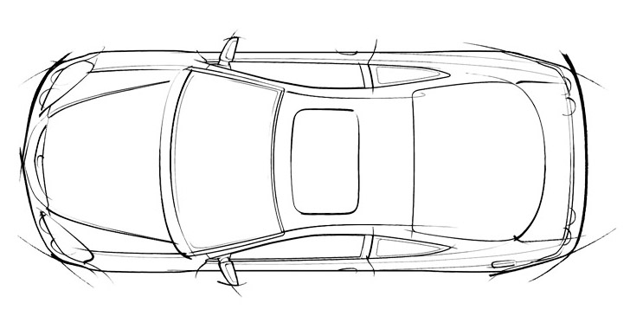

Rear

Front

Were you: Surprised by impact? Braced for impact?

Did you lose consciousness? Yes No Unsure

Did you exit the vehicle on your own? Yes No

Please describe the accident in your own words: __________________________________________________

__________________________________________________________________________________________

__________________________________________________________________________________________

__________________________________________________________________________________________

__________________________________________________________________________________________

Patient name: _______________________

**PLEASE MARK YOUR SYMPTOMS ACCORDINGLY ON THE DIAGRAMS BELOW**ACHING: XXXX NUMBNESS: ==== PINS & NEEDLES: 0000  
BURNING: >>>> STABBING: //// THROBBING: ++++

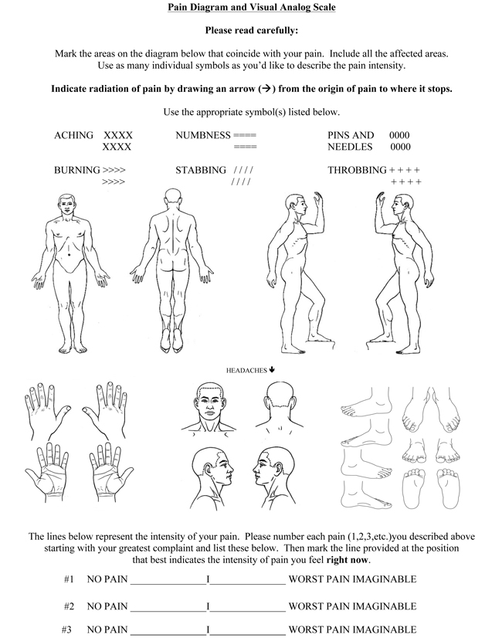

Describe your pain:

Prior injury to this body part? _________When, where, and what type of imaging have you had to this area? ______________­­­ If this is a work-related injury, please describe the type of work you do: ________________

Any Fever, chills, cough, shortness of breath, unintentional weight loss, and night sweats Yes No

|  |  |  |  |  |  |  |  |  |  |
| --- | --- | --- | --- | --- | --- | --- | --- | --- | --- |
| If yes please list ____________________________  Check the conditions you are experiencing: | | | | | | | | | |
|  | Loss of bowel |  | Memory issues |  | Joint locking |  | Weakness |  | Dizziness |
|  | Loss of bladder |  | Radiating pain |  | Joint giving way |  | Numbness |  | Not sleeping |

* Are you working? Yes No Regular work or Modified (light) duty work   
  Are you receiving time-loss benefits (being paid by the insurer)? Yes No

**Please circle your average daily pain score below**

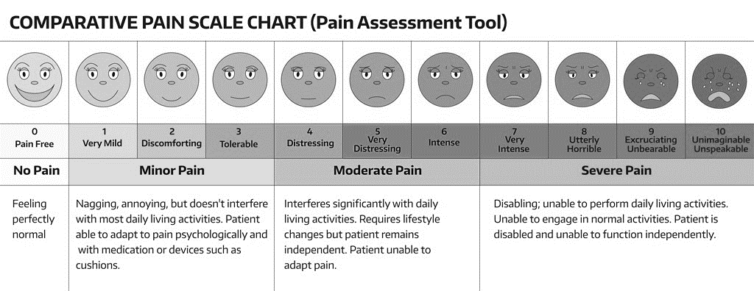

**Assignment of Insurance Billing**

I request Integrated Rehabilitation, Inc. (IR) bill my insurance and accept the assignment of my coverage. I direct and assign the proceeds of any benefit, settlement, recovery, or judgment to be paid directly to IR up to the entire amount owing to IR. I allow IR to apply any insurance payments to my bill, and I promise to pay the remainder, regardless of the insurance company’s amount of assignment or determination of usual and customary rates.

I understand and agree that health and accident insurance policies are an arrangement between an insurance carrier and myself. Furthermore, I understand that it is my responsibility to make collections from the insurance company. I understand that any amount authorized to be paid directly to IR will be credited to my account upon receipt. However, I clearly understand and agree that all services rendered to me are charged directly to me and that I am personally responsible for payment. I understand that IR bills my insurance carrier as a courtesy, and I agree to promptly pay any amount that is not paid to IR by my insurance company within 90 days. I also understand that if I suspend or terminate my care and treatment, any fees for professional services rendered to me will be immediately due and payable.

**Authorization for Treatment**

I (the undersigned) authorize the treatment of the person above by the doctors and staff of IR, to include various modes of licensed massage therapy, acupuncture, and physical therapy which may include chiropractic manipulation/adjustments and/or other chiropractic procedures. I authorize and approve treatment by any licensed doctor or provider (or qualified staff member) who now or in the future may be employed by, working with, or associated with IR (or substituting for such doctor or staff member), including those working at IR or any other office or clinic where I may be referred.

I certify that the information I have given on this form and during my examination is true, correct, and complete to the best of my knowledge. I also certify that, to the best of my knowledge, the areas of pain and physical complaints I have reported are related to the injury or accident stated. I will not hold the doctor or IR responsible for any errors or omissions that I may have made in my answer. I understand and agree that the doctor will not be held responsible for any pre-existing medically diagnosed conditions, or any medical diagnosis.

Patient signature: Date:

Patient’s representative’s signature: ______________________________ Relationship:   
 (if patient cannot sign)

Print patient name:

**Financial Policy Acknowledgment**

We are committed to providing you with the best possible care. If you have insurance, we are happy to help you receive your maximum allowable benefits. In order to achieve these goals, we need your assistance and understanding of our payment policies.

* You will need to provide our office with a copy of your driver’s license or state-issued identification card and health insurance card or your claim number and carrier information. Treatment may be postponed if this information is not provided. Advance verification of insurance benefits is required.
* For your convenience, we accept payment via cash, personal check, debit, and credit.
* Self-pay patients are required to pay $300.00 at the time of service for new patient consultation and $150.00 at the time of service for follow-up visits with Dr. Kane or his physician’s assistant.
* Phone management for coordination of care and/or medication management may be subject to a $35.00 charge.
* Cancellation of all appointments requires 24 hours’ notice otherwise you will be charged $35.00. This includes appointments for physical therapy, massage, acupuncture, and phone or office visits with the doctor.
* Motor vehicle accident patients are required to check their PIP amount to ensure funds are available. Back-up commercial insurance will be required. If we do not accept your commercial insurance, you will need to make self-pay arrangements.
* All accounts are due and payable, including copays and deductibles, at the time of service unless payment arrangements have been made in advance with our billing department.
* Primary insurance will be billed by the clinic as a courtesy. It is the responsibility of the patient to verify that the clinic has the correct insurance information and to inform the clinic if there are any changes with their insurance provider. Any questions or disputes about the insurance policy will need to be resolved between the patient and the insurer.
* Please be aware that many insurance companies assign copays to the office portion of your visit. Injections, manipulations, exercise therapy, massage, diagnostics, and laboratory work are considered separate from the office visit and may be subject to your deductible and copays.
* Durable medical equipment (DME) such as braces, splints, heel lifts, and custom orthotics will be billed to your insurance. In the event they are not covered, the patient will be responsible for the cost of the equipment.
* In the event that we have to turn your account over to a collection agency, any reasonable fees, collection fees, and/or attorney’s fees may be added, including but not limited to, an interest rate of 9% per annum from your original date of delinquency.
* All forms including FMLA and Disability paperwork will be charged a minimum of $35.00 for the physician to complete the forms. This charge will not be billed to the insurance carrier as it is the responsibility of the patient.

I acknowledge that I am financially responsible for all charges whether my insurer pays or not. I have been advised that if my insurance company does not wish to cooperate in paying the fees, the doctor will not await payment, but will require me to pay in full or arrange for payments on a monthly basis. A photocopy of this authorization shall be considered as effective and valid as the original. If it becomes necessary to effect collections of any amount owed on this or subsequent fees, the undersigned agrees to pay for all costs and expenses, including reasonable attorney fees. I hereby authorize the doctor to release information necessary to process claims and to secure payment directly from the insurance carrier.

Patient signature: Date:

Patient’s representative’s signature: ______________________________ Relationship:   
 (if patient cannot sign)

Print patient name:

**Notice of Patient Privacy**

We are committed to preserving the privacy of your personal health information (PHI). We are required by law to protect the privacy of your medical information and to provide you with a notice describing how your medical information may be used and disclosed and how you can access this information.

* We may use or disclose to others your medical information both created and received by the practice in the form of written or electronic records or spoken words for the purpose of providing or arranging for your health care, the payment for or reimbursement of the care that we provided to you, and the related administrative activities supporting your treatment. The information disclosed may include information about your health history, health status, symptoms, examination, test results, diagnoses, treatments, procedures, prescriptions, and similar types of health-related information.
* We may be required or permitted by certain laws, regulations, or circumstances to use and disclose your medical information for other certain purposes without your consent or authorization. Under other circumstances, we may need your written authorization (that you may later revoke) in order to use or disclose your medical information.
* As our patient, you have important rights relating to inspecting and copying the medical information that we maintain, amending or correcting that information, obtaining an accounting of our disclosures of your medical information, requesting that we communicate with you confidentially, requesting that we restrict certain uses and disclosures of your health information, and complaining if you think your rights have been violated.
* We have available a detailed Notice of Privacy Practices which fully explains your rights and our obligations under the law. We may revise our Notice from time to time.
* You have the right to receive a copy of our most recent Notice of Privacy Practices. If you have not received a copy, please inquire at the front desk.
* If you have any questions, concerns, or complaints about the Notice or your medical information, please contact the Office Manager at 503-232-1000.
* At this office, we have multiple patients who are being treated by different providers at one time. When this occurs, you may be visible to other patients and may be able to be overheard when speaking with them or our staff. We strive to maintain your privacy as much as possible during treatments.

Patient signature: Date:

Patient’s representative’s signature: ______________________________ Relationship:   
 (if patient cannot sign)

Print patient name:

**Late Cancelation and No-Show Policy**

When you are scheduled for a visit to our clinic, we are reserving time and reviewing and preparing documents for your health care needs. We kindly ask that you provide our office with at least 24 hours’ notice for cancelation and/or rescheduling of your appointment so that we may offer your appointment time to another patient. Please speak directly with a staff member. Voicemails left after reception office hours or during the weekend may not be accepted as proper notice. **Appointments that are canceled with less than 24 hours’ notice are subject to a $35.00 cancelation fee. This fee is payable by the patient and will not be billed to your insurance.**

**We reserve the right to discontinue treatment and discharge you from the practice.**

Please sign below indicating you understand our late cancelation and no-show policy.

Patient signature: Date:

Patient’s representative’s signature: ______________________________ Relationship:   
 (if patient cannot sign)

Print patient name:

**Office Policies**

Business Hours

Office reception hours: Monday through Friday, 8:00 am to 5:00 pm.

Phone Calls

Messages are checked throughout the day and calls are returned in a timely fashion. Messages left after 3:00 pm will be returned the next business day. Please do not leave multiple messages as this will only delay our response time and may result in discharge from the clinic.

Walk-Ins

We do not see patients without an appointment. It is very difficult for our staff when their workflow is interrupted by unscheduled patients. If you have a question or concern, please call the office, and leave a message for the appropriate staff member.

Prescription Refills

Call your pharmacy’s automated refill line to initiate refills of medication and allow at least **48 hours** to be filled.

**If you are out of refills with your pharmacy, call our office at 503-232-1000 option 5, Please only call our medication refill line. Do not leave multiple messages**. **Please call 48 hours before your medication needs to be refilled.**

We do not process medication refills on Fridays, Saturdays, or Sundays. Please ensure you have called in your prescription to be filled before your refill date.

If you are unable to wait until business hours for medication or medical attention, please present to urgent care or the emergency department for your health care needs.

We will not replace lost or stolen medication. For stolen medication, please contact the local police and file a report, then contact our office with the officer’s name and number, and your case number. This may allow us to refill your medication.

We do not allow concurrent use/abuse of opioid pain medication with illicit drugs, marijuana, and/or alcohol. Please disclose the substances you use so that we may discuss alternatives for your pain management.

Patient signature: Date:

Patient’s representative’s signature: ______________________________ Relationship:   
 (if patient cannot sign)

Print patient name: